Constant temperature and humidity machine.
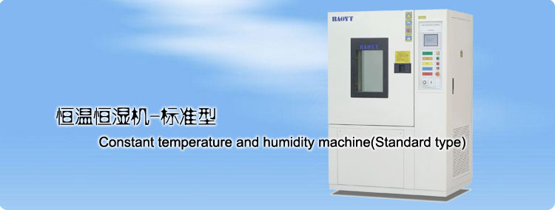
Constant temperature and humidity machine aims to test the product whether the adaptive ability and features will change, under a certain climate(high&low operation&storage, temperature circulation, high temperature and humidity, low temperatue and humidity, condensation test etc.)
※Must be in accordance with International syandards(IEC,JIS,GB,MIL) so as to achieve a coherence of International testing programs(including test procedures,conditions, ways)
Product Features:
◆The same volume can withstand larger storage area and load heat.
◆The new PWM cold media control technology is adopted to realize low temperature energy-saving operation.
◆Prevent the products from uncondensable.
◆Communication configuration RS232 interface and USB storage download function.
◆Multiple alarm monitoring of machine station, configure wireless remote alarm function.
◆Safest water system and Recycled water circulation system.
◆Humidity effect able to reach 15℃/5%RH efficiency, fast dehumidification.
◆Strong ability on preventing static electricity consumption, to achieve the best performance in the industry.

Refrigeration advantages:
Traditional low temperature control mode: Refrigeration compressor start and stop control temperature(large temperature fluctuation,Severe impact on compressor life,obsolete technology); Constant operation of refrigeration compressor+heating PID control（temperature dynamic balance is realized by means of cooling and heating, waste of electric energy）New mode PWM Cold control technology realizes low temperature energy saving operation：low temperature working status,the heater does not work，Control the flow of refrigerant by PWM technology. Regulates three flows for refrigeration pipe, cold bypass pipe, hot bypass pipe, realize automatic constant temperature of the working roo, under such low-temperature working condition,energy consumption can be reduce by 40%。

The technology is based on the American Sporlan company's customized PWM control valve.
Because the technology is able to achieve the regulation of the pipeline flow by frequent working of solenoid valve. Standard solenoid is not suitable and metal fatigue damage will occur in a short time. The high-performance valves currently supporting the technology are only XM series produced by American Sporlan(The product cannot be imported from normal channels). The following figure is the difference between two solenoid valves.
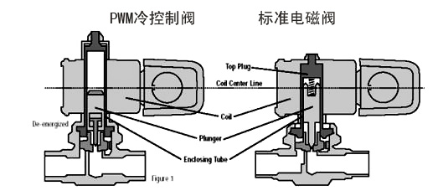

Application Standards:
Standards implemented and met
1.GB/T10589-1989 Technical conditions of low temperature test box.；
2.GB/T10586-1989 Wet and heat test box technical conditions.；
3.GB/T10592-1989 High and low temperature test box technical conditions.
4.GB2423.1-89 low temperature test Aa,Ab ；
5.GB2423.3-93（IEC68-2-3）constant temperature and climate test Ca；
6.MIL-STD810D method 502.2；
7.GB/T2423.4-93（MIL-STD810）method 507.2 program3；
8.GJB150.9-8 temperature and climate test；
9.GB2423.34-86、MIL-STD883C method1004.2 temperature and humidity combined cycle test.
10.IEC68-2-1 testA
11.IEC68-2-2 testB high-low temperature cycling
12.IEC68-2-14 testN

Technical parameters:
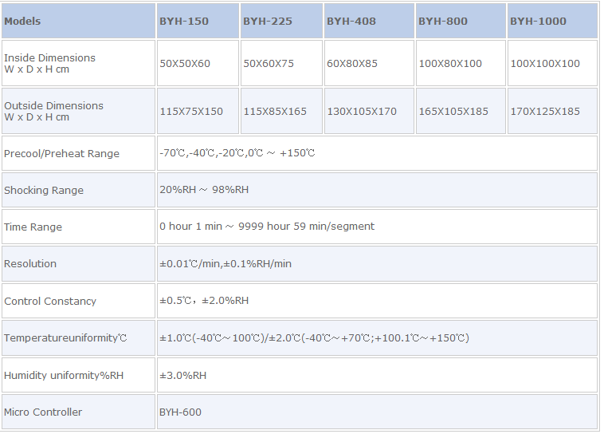

Temperature control rate list.
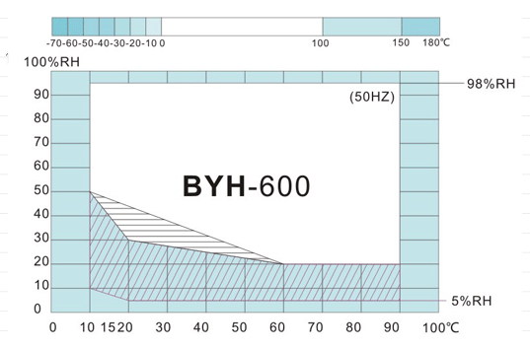
■ The oblique part is the curve of chemical dehumidification system.
■ The horizontal part is 60Hz，the rest is the curve of 50Hz。
■ 50Hz control range
■ 60Hz more than 50Hz ability range
■Ability to install dehumidification wheels
Product selection schematic.

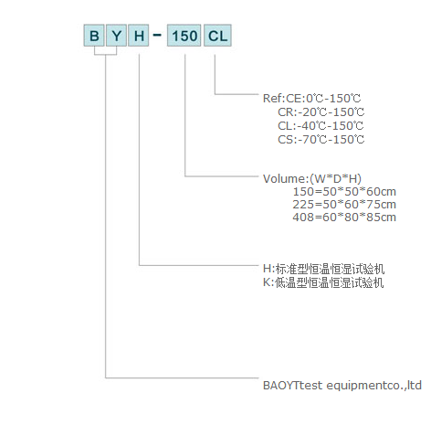
Note: The temperature and humidity distribution uniformity test method is based on 1/10 distance effective space measurement of the inner box from each side (GB5170.18-87)

